# Bug 4 – Debugging Log

Hypothesis 1:

|  |  |
| --- | --- |
| Hypothesis | Dice.getValue() is not receiving varying face values |
| Prediction | All round dice rolls are identical to the first |
| Experiment | Run game and observe |
| Observation | Dice rolls were identical as per prediction |
| Conclusion | Dice.getValue() must be producing incorrect results |

Bug Resolution:

To resolve the bug we the value needs to be called in the roll not only initialised in the constructor which can be changed calling the value in the getValue() method demonstrated in the before and after screenshots:

Before:

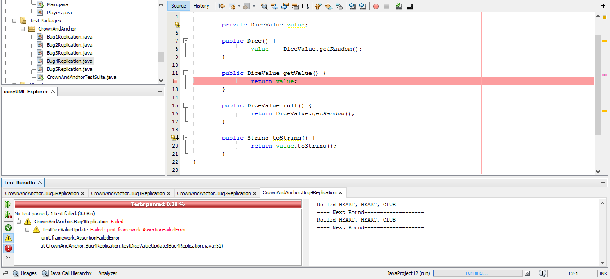

After: 